Directory Management System Project

Phase I Part 1
Use Astah to draw a class diagram. Use proper UML notation. Take a clear screenshot of your completed diagram and paste it on this page.

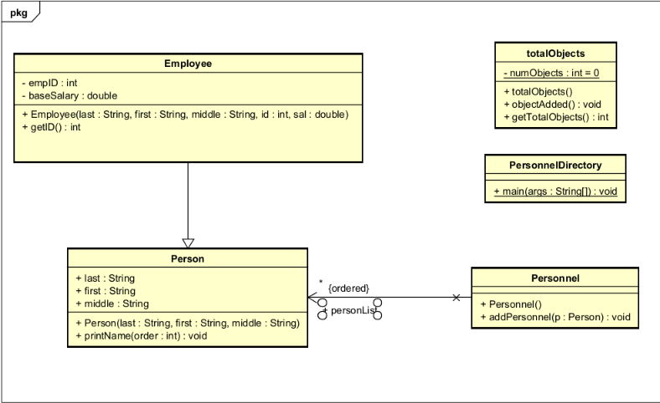

Phase I Part 2
Identify the places in the code where there are object-oriented concept violations, content coupling, common coupling, control coupling, and stamp coupling situations. On this page, paste the code segments that correspond to each situation and explain how you would fix object-oriented concept violations, common coupling, control coupling, and content coupling issues. You may add pages if necessary.

PersonnelDirectory.java
Content Coupling - PersonnelDirectory is directly adding to the personList.
Fix: Utilize the helper function in the Personnel.java class. Change line of code to ‘per.addPersonnel(p1)’

Person.java

Control Coupling – The function printName(int order) utilizes the integer as a flag for which order to put the name in rather than passing the integer as pure data
Fix: Remove printName function, turn each option to its own function and move the selection process to PersonnelDirectory (where printName is being called)

Employee.java
Object-Oriented Violation – There is no accessibility to the baseSalary variable to receive or alter its content
Fix: Add getter and setter methods to the class

Employee.java
Object-Oriented Violation – These variables should be private to ensure encapsulation
Fix: Change these variables to private. Add getter and setter methods to the class if changing the name at any point is required

Personnel.java
Object-Oriented Violation – Variable should be private to ensure encapsulation. PersonnelDirectory directly accesses the variable’s
Fix: Change these variables to private. Add getter and setter methods to the class if changing the name at any point is required

Phase II Part 2
After you have incorporated the PersonnelFactory, use Ashta to draw a UML class diagram of the Personnel Directory. Use proper UML notation. When you have completed your diagram, take a clear screenshot of your diagram and paste it on this page.



